LINKING YOUR CM/ECF ACCOUNT TO YOUR
UPGRADED PACER ACCOUNT

To link your existing CM/ECF account to your upgraded PACER account:

- Go to the court’s CM/ECF site (https://ecf.flnb.uscourts.gov) and click the link to login. You will be redirected to the PACER login screen.
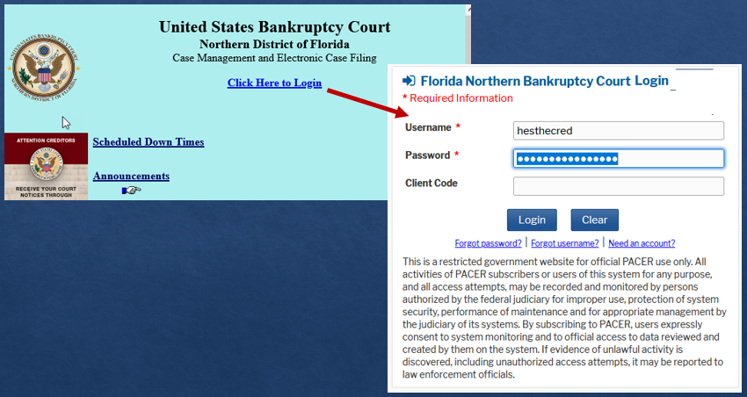

- Enter your PACER login credentials. Do not log on using a shared firm PACER account.

- Click Utilities then select My PACER Account.
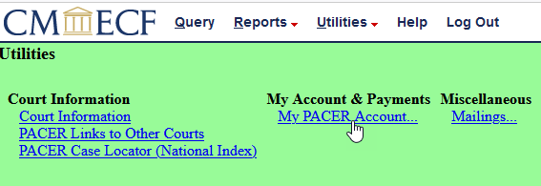

- Select Link a CM/ECF Account to my PACER account.

- Enter your Florida Northern Bankruptcy Court CM/ECF login and password and click the Submit button.
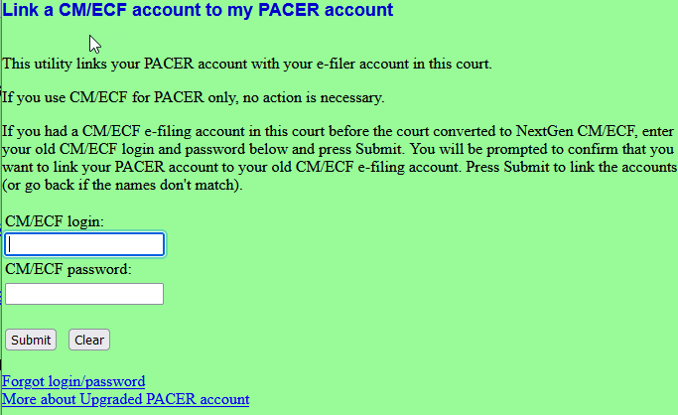

jgibson

- Confirm that the accounts to be linked are accurate and click the Submit button. You will receive a message that the accounts have been linked successfully.

- Refresh your screen or clear your cache and the Bankruptcy and Adversary menu options for filing should appear in the white menu bar at the top of your screen.

